- Screenshot of docker build output

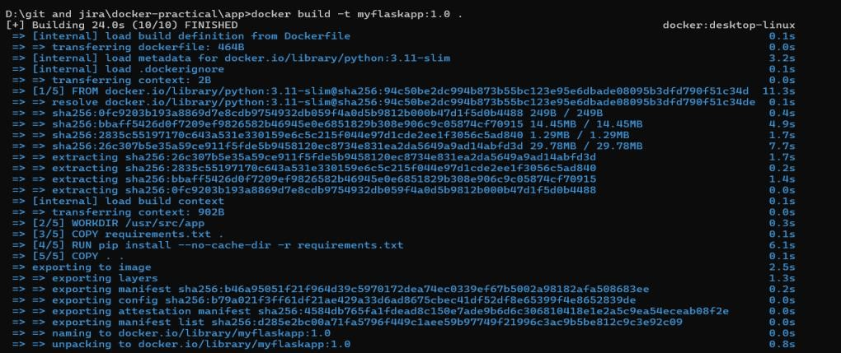

- Screenshot of docker images

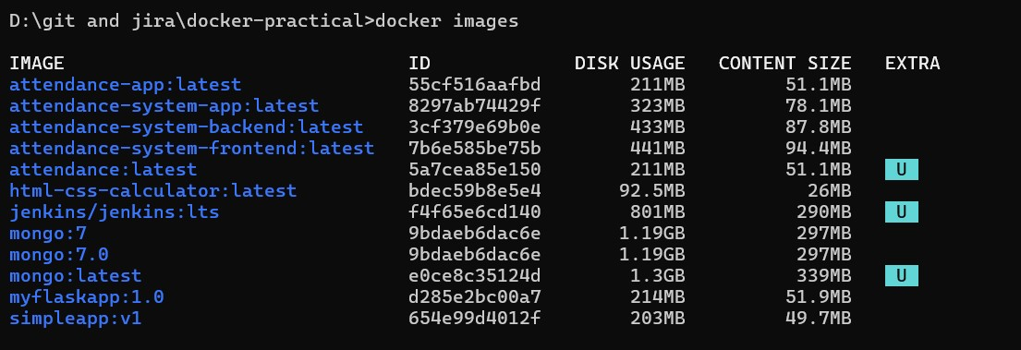
- Screenshot of docker network inspect app-network

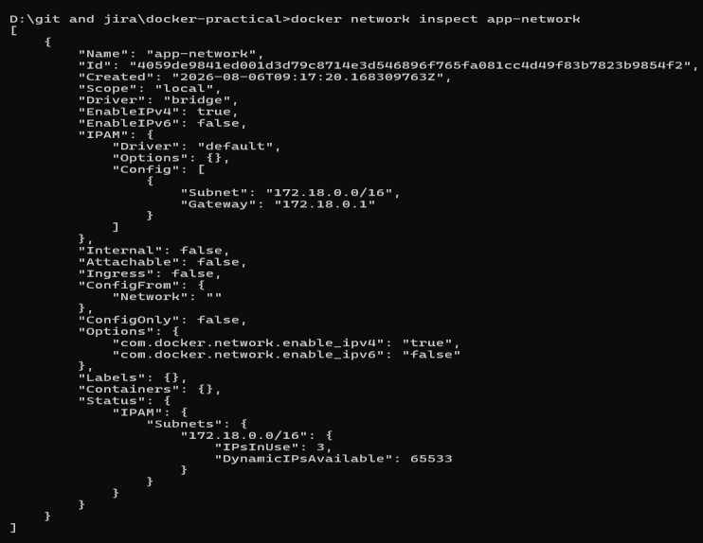
- Screenshot of docker volume inspect redis-data
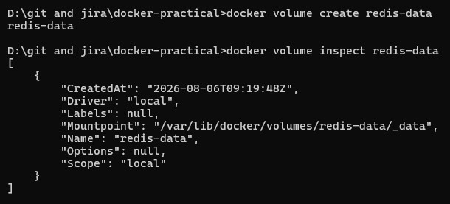
- Screenshot showing counter incrementing across curl requests

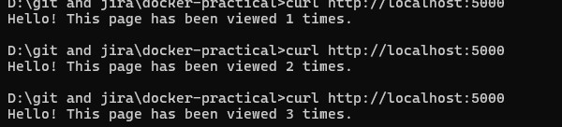
- Screenshot showing counter persisting after container recreation
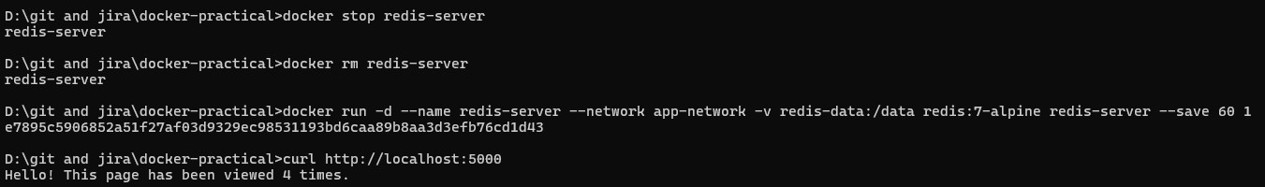
- Screenshot showing failed ping (outside network) and successful ping (inside network)
